|  |
| --- |
| **PHP Project Feature Specifications** |

|  |
| --- |
|  |
| Project Name: [www.humbermatrimony.com](http://www.humbermatrimony.com)  Submitted To: Bernie Monette  Submitted By: Jagsir Singh Ghatore - Team Zenith |

|  |
| --- |
| Jagsir Singh  2/20/2014 |

Profile Page

**Narrative Description**

Profile page is the main landing page for registered users after the login. Once user successfully logs in, profile page display all his details. At the registration time user does not fill complete profile information. To make the account more searchable, user needs to provide the complete information. On this page users provide their missing information and they can change their existing information details like basic details, professional details, religious details, partner preferences, locations, and family details. Each part will be separate and will have edit button. By clicking on this button, text boxes will appear containing existing information and with buttons to save and cancel. Users can change their own profile information. Same page is used to display the information for other member’s information but without edit buttons. This page will have link to image gallery page. If user is viewing personal image gallery then user can upload and delete images but if it is someone else’s image gallery then no changes are allowed.

Database tables for this feature are like below:

tbl_Users

|  |  |
| --- | --- |
| User Id | Numeric **(PK)** |
| First Name | Text 45 characters |
| Last Name | Text 45 Characters |
| Email | Text 45 characters |
| Phone | Text 45 characters |
| User Name | Text 45 characters |
| Password | Text 45 characters |
| Role Id | Text 45 characters |

tbl_UserBasicDetails

|  |  |
| --- | --- |
| User Id | Numeric **(FK)** |
| Gender | Text 1 character |
| Age | Numeric |
| Date of Birth | Date |
| Created For | Text 45 characters |
| About User | Text 500 characters |
| Body Type | Text 45 characters |
| Complexion | Text 45 characters |
| Physical Status | Text 45 characters |
| Height | Float |
| Weight | Float |
| Mother Tongue | Text 100 characters |
| Drink Habits | Text 100 characters |
| Smoke Habits | Text 100 characters |
| Eating Habits | Text 100 characters |
| Hair Color | Text 45 characters |

tbl_UserHobbies

|  |  |
| --- | --- |
| User Id | Numeric **(FK)** |
| Hobbies | Text 500 characters |
| Interests | Text 500 characters |
| Dress Style | Text 45 characters |
| Spoken Languages | Text 100 characters |

tbl_UserImages

|  |  |
| --- | --- |
| Image Id | Numeric **(PK)** |
| User Id | Numeric **(FK)** |
| Image | Text 45 characters |
| Thumbnail | Text 45 characters |
| Is Main Image | True / False |

tbl_UserLocations

|  |  |
| --- | --- |
| User Id | Numeric **(FK)** |
| Country Id | Numeric |
| State Id | Numeric |
| City Id | Numeric |
| Citizen | Text 45 characters |
| Resident Status | Text 45 characters |

tbl_UserProfession

|  |  |
| --- | --- |
| User Id | Numeric **(FK)** |
| Education | Text 500 characters |
| College | Text 500 characters |
| Additional Degree | Text 500 characters |
| Occupation | Text 45 characters |
| Employed In | Text 45 characters |
| Annual Income | Decimal (7,2) |

tbl_UserProfession

|  |  |
| --- | --- |
| User Id | Numeric **(FK)** |
| Living With | Text 45 characters |
| Siblings | Numeric |
| Married Sisters | Numeric |
| Married Brothers | Numeric |
| Father Occupation | Text 45 characters |
| Mother Occupation | Text 45 characters |

tbl_UserPartnerPreferences

|  |  |
| --- | --- |
| User Id | Numeric **(FK)** |
| Age From | Numeric |
| Age To | Numeric |
| Religion | Text 100 characters |
| Cast | Text 100 characters |
| Country | Text 100 characters |
| Resident Status | Text 45 characters |
| Citizen | Text 45 characters |
| Height | Float |

**The Dataflow Models**

To add missing information or to change existing information, users are required to log in. They will see an edit button for each section. Information is categorised by nature. So, when user clicks on edit button it will open specific section for editing. After filling required information, on click of submit button information will be saved into particular database table.

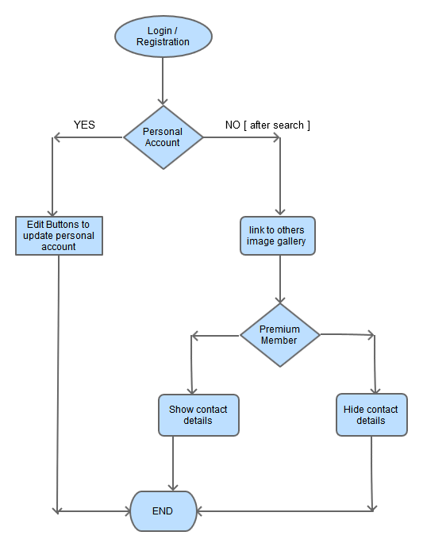

Here is flow chart for process of uploading personal images

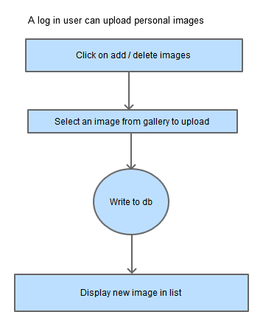

Flow chart to delete an image

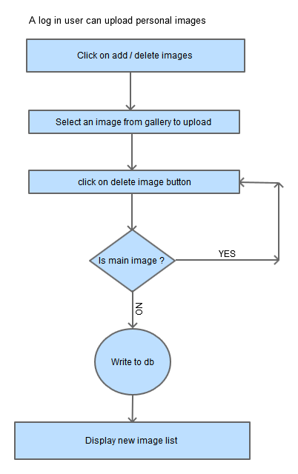

If user is looking at others profile and feels really like it then can send interest.

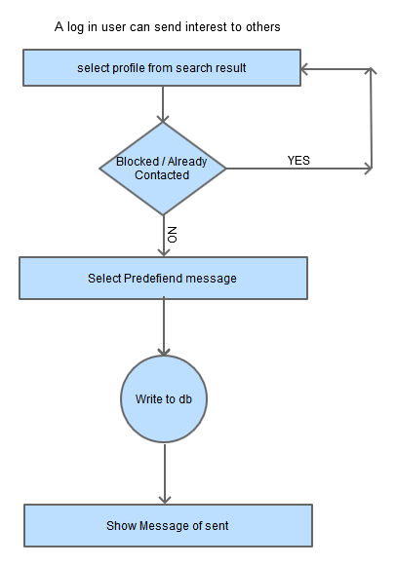

**Wireframes**

Here is the wireframe for personal profile display

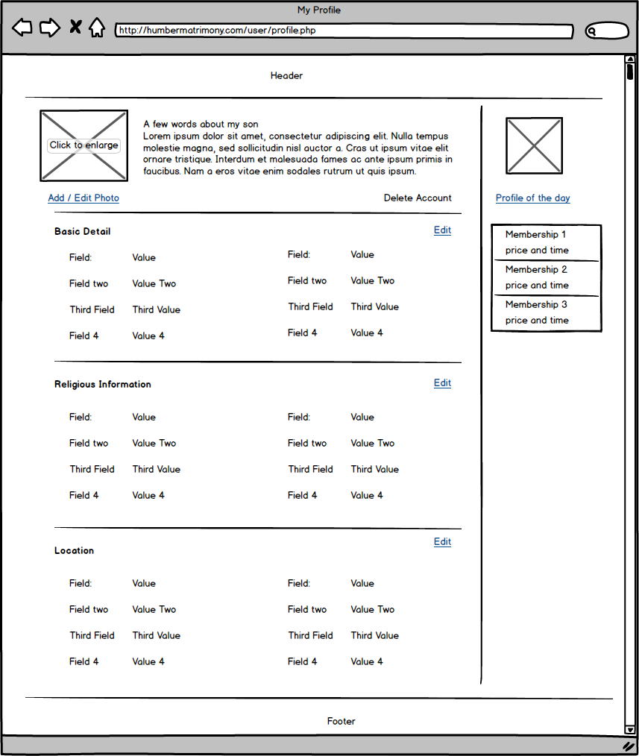

Wireframe for Edit Profile page is below

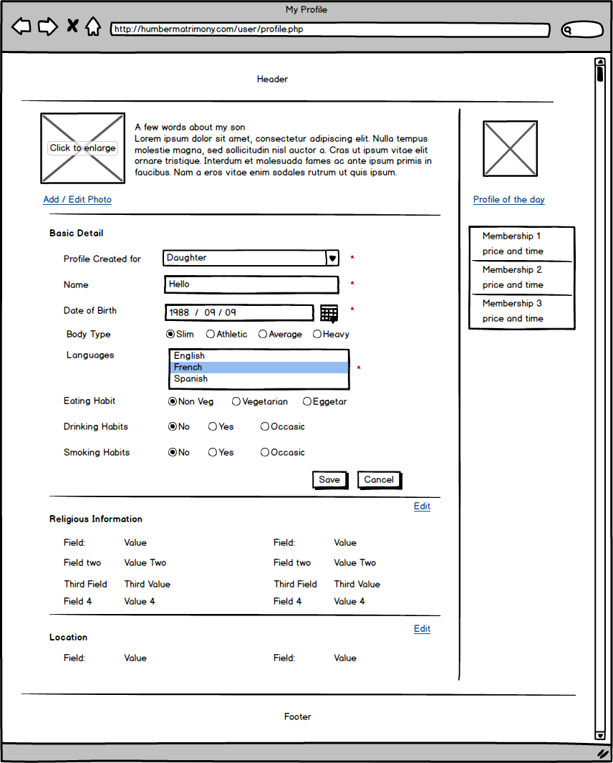

When user is viewing others profile page then it will look like below

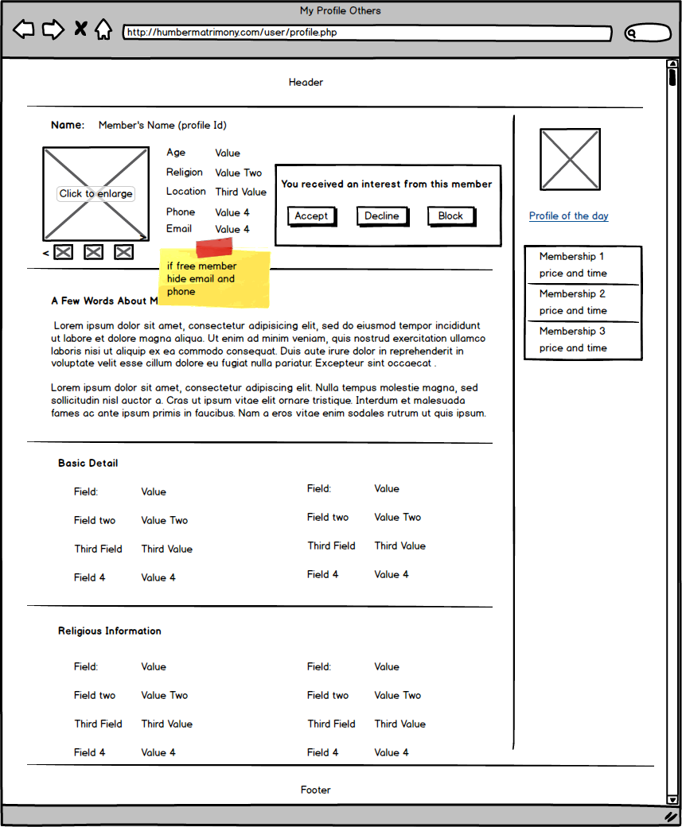

Wireframe for the personal image gallery

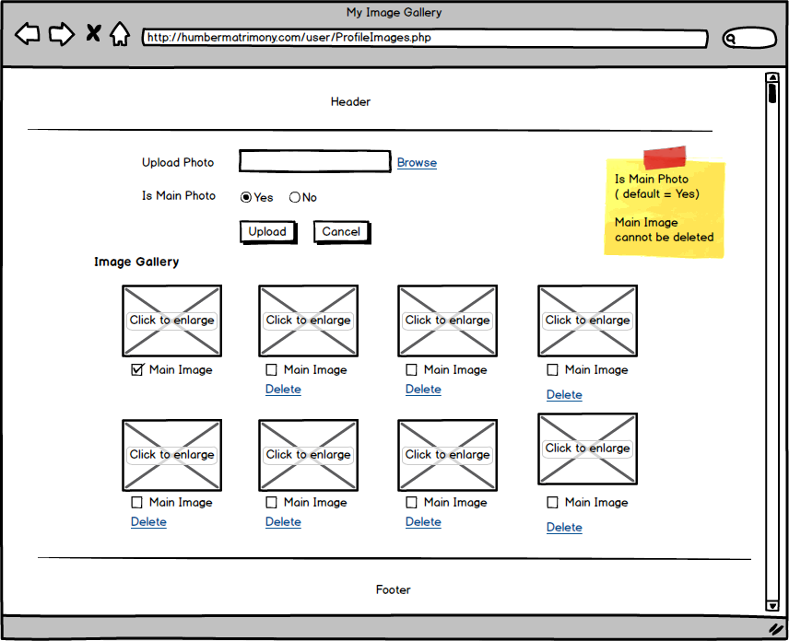

Wireframe for image gallery of others

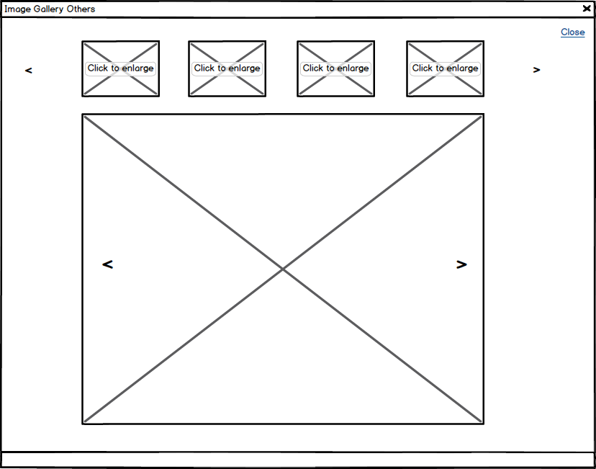

Support Tickets

**Narrative Description**

Website will provide technical, billing, and general support to registered users. Users can submit tickets regarding any of these areas and within time frame; they will get a reply from the administration. They will be able to upload files to support their query. If administration is able to resolve the issue or query then users should be asked to close the ticket and if they don’t, ticket will be closed after 24 hours of last reply.

Database tables for this feature are below:

tbl_SupportTicket

|  |  |
| --- | --- |
| Support Ticket Id | Numeric **(PK)** |
| Sender User Id | Numeric **(FK)** |
| Subject | Text 45 characters |
| Submit Date | Date |
| Is Closed | True / False |
| Department ID | Numeric |

tbl_SupportTicketHistory

|  |  |
| --- | --- |
| Support Ticket Id | Numeric **(FK)** |
| Sender User Id | Numeric **(FK)** |
| Agent User Id | Numeric **(FK)** |
| Message | Text 500 characters |
| Message Date | Date |
| Is Replied | True / False |

**The Dataflow Models**

First users are required to be registered and need to log into account. They will see navigation for support and first time they have to raise a ticket by providing department, subject, and message. When user is done filling the information, submit button will save the information in database table and this ticket will display on admin dashboard. Once information is saved into database, users will get an email. Once agent sees the ticket he/she can reply or delete the ticket. Users will have to close the ticket when they feel satisfied and if they do not close or put another question within 24 hours, system will automatically close the ticket. However, users can reopen the same ticket

Data flow model for ticket process is below

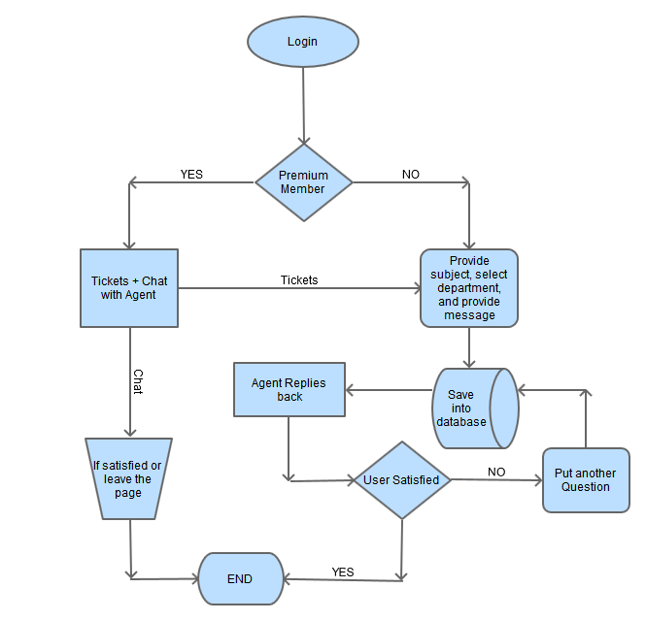

**Wireframes**

Wireframe to raise a ticket is below

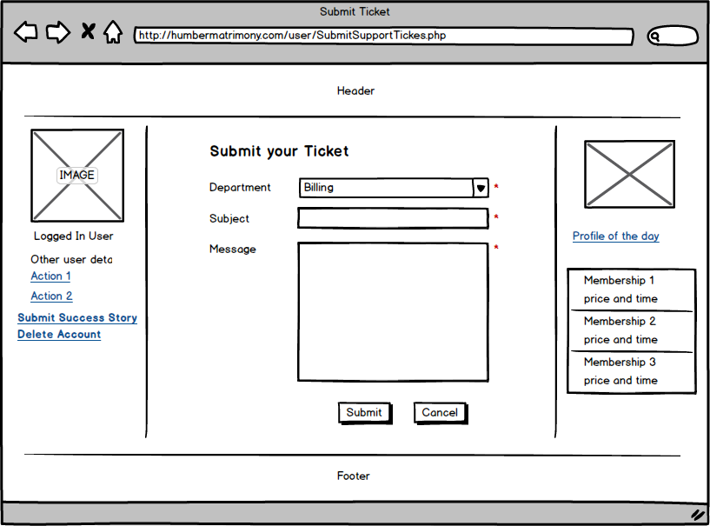

Wireframe for reply to ticket by user

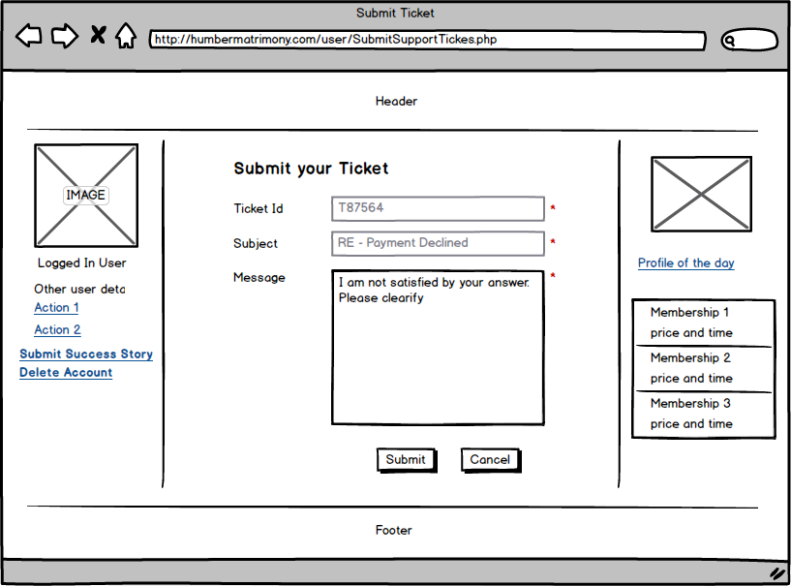

Wireframe for ticket history by admin agent

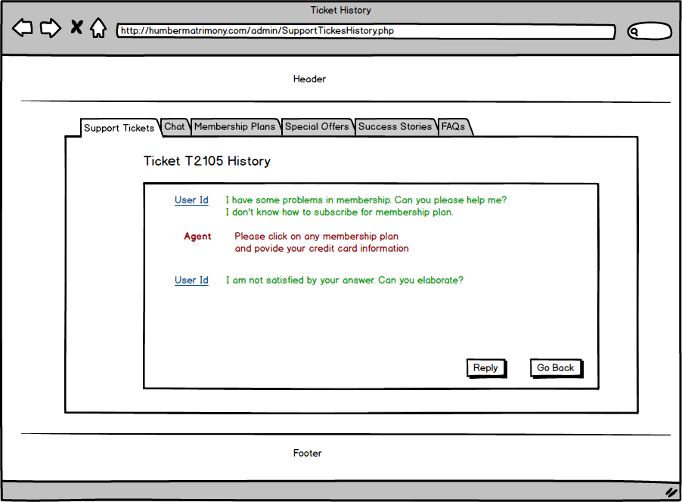

Wireframe for ticket history by users

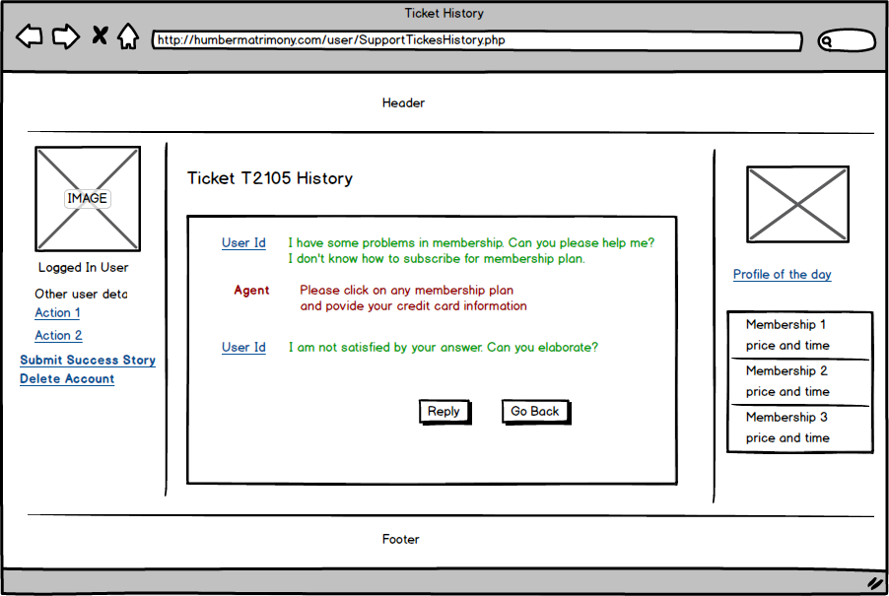

Wireframe for reply to the question from user (admin section)

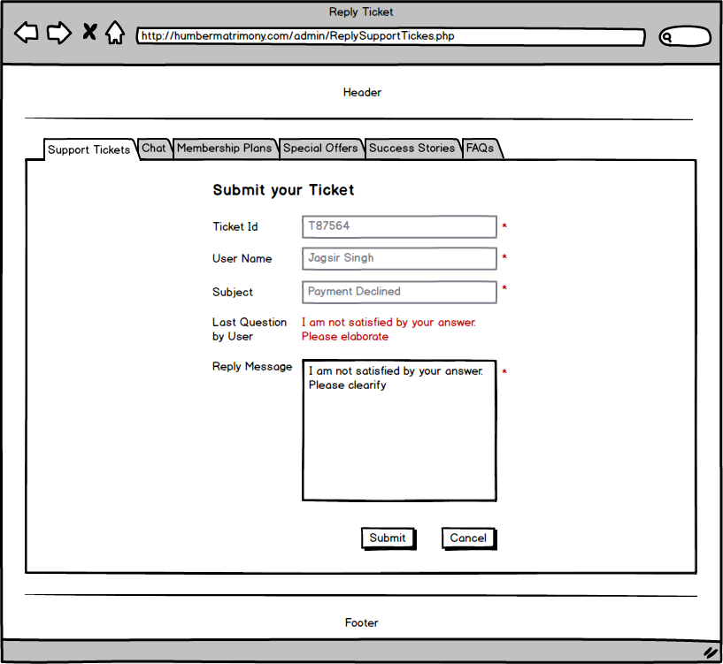

Wireframe to display all tickets in admin section

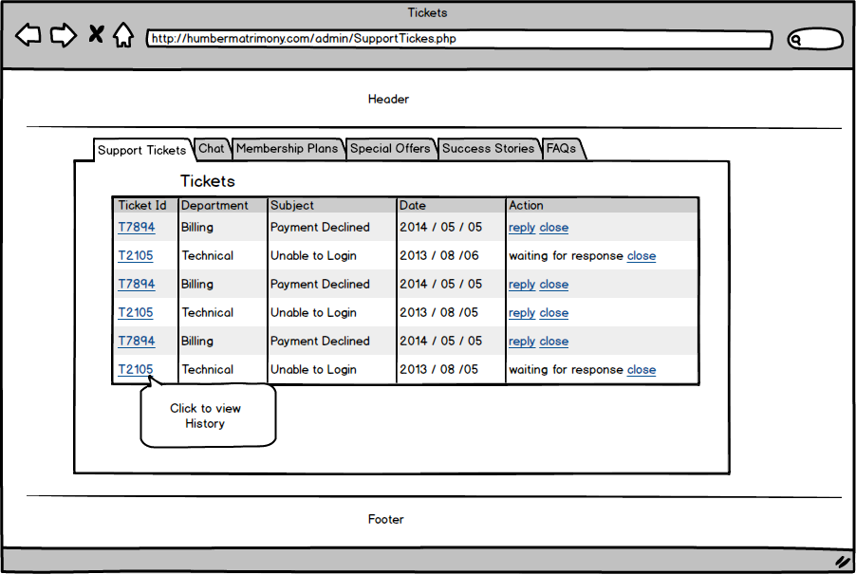

Wireframe to display all tickets in user section

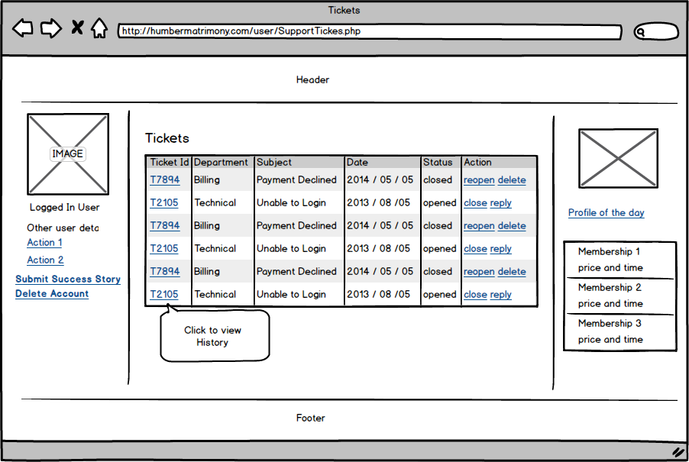

Membership Plans

**Narrative Description**

Admin will have an interface to insert / update membership plans for users. Each membership plan will have specific duration, limited number of contacts allowed, and different price. Premium members will have some other facilities also; such as the ability to protection of personal images, live chat with others, and live chat with agents. Users can select any one of these choices to become premium members. The website will use a PayPal gateway for the monetary transactions. After a successful transaction, users will get an email and their account will be upgraded to premium account right away. They will get an automated receipt from the website in their email for future references. Users will have to provide their financial information like credit card information to pay the required fees.

Following database tables are used for the memberships

tbl_ Memberships

|  |  |
| --- | --- |
| Membership Id | Numeric **(PK)** |
| Membership Title | Text 45 characters |
| Days Allowed | Numeric |
| Contacts Allowed | Numeric |
| Price | Decimal(7,2) |
| Comments | Text 500 characters |

tbl_ Memberships

|  |  |
| --- | --- |
| User Membership Id | Numeric **(PK)** |
| Membership ID | Numeric **(FK)** |
| User Id | Numeric **(FK)** |
| Start Date | Date |
| End Date | Date |
| Allowed Contacts | Numeric |
| Viewed Contacts | Numeric |

tbl_ MembershipPaymentHistory

|  |  |
| --- | --- |
| Membership Payment Id | Numeric **(PK)** |
| User Membership Id | Numeric **(FK)** |
| Payment Date | Date |
| Confirmation Number | Text 45 characters |

**The Dataflow Models**

Users can subscribe to any one plan either on registration time or they can do it later. Here is the dataflow model to subscribe to the membership plan

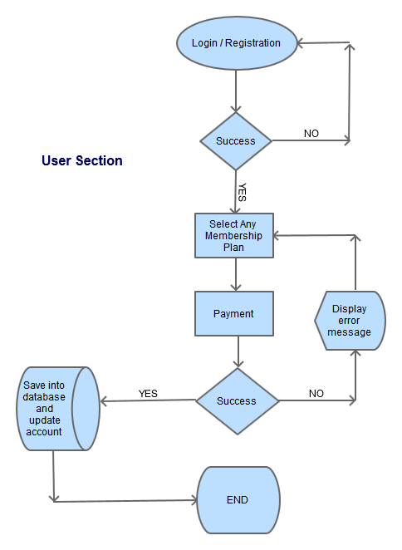

Dataflow model for admin section to add / update membership plans

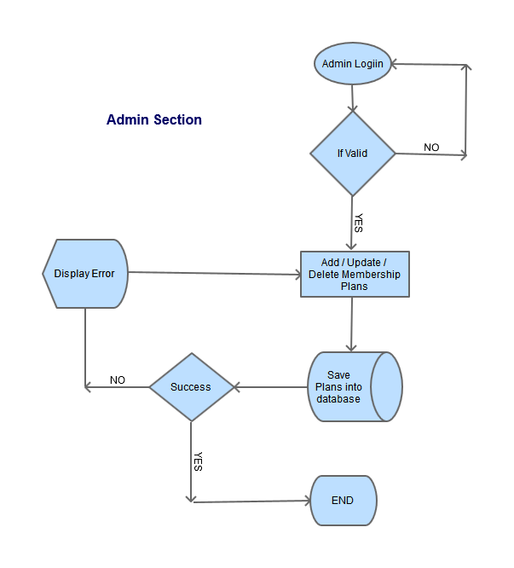

**Wireframes**

Wireframe display all membership plans in admin section

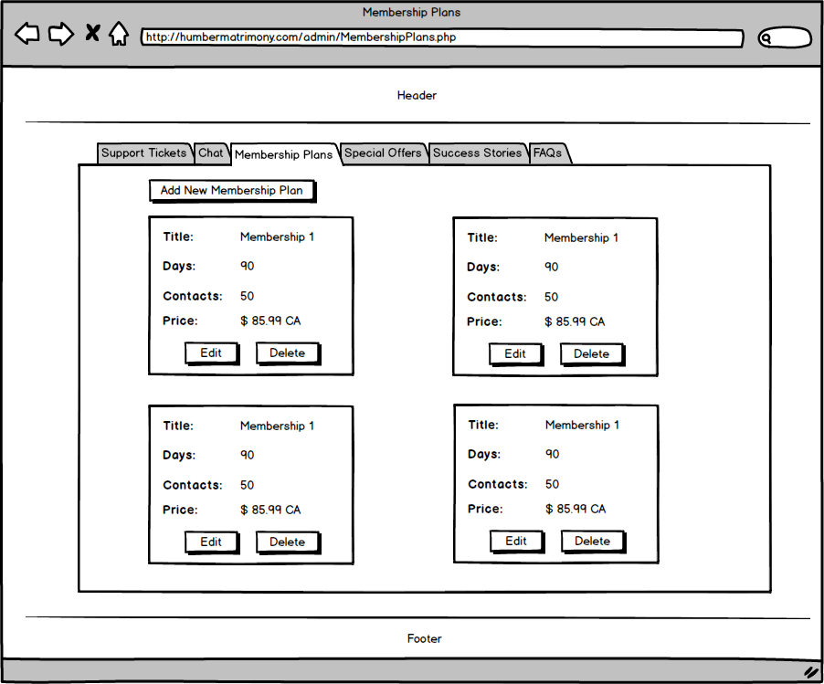

Wireframe display all membership plans in user section

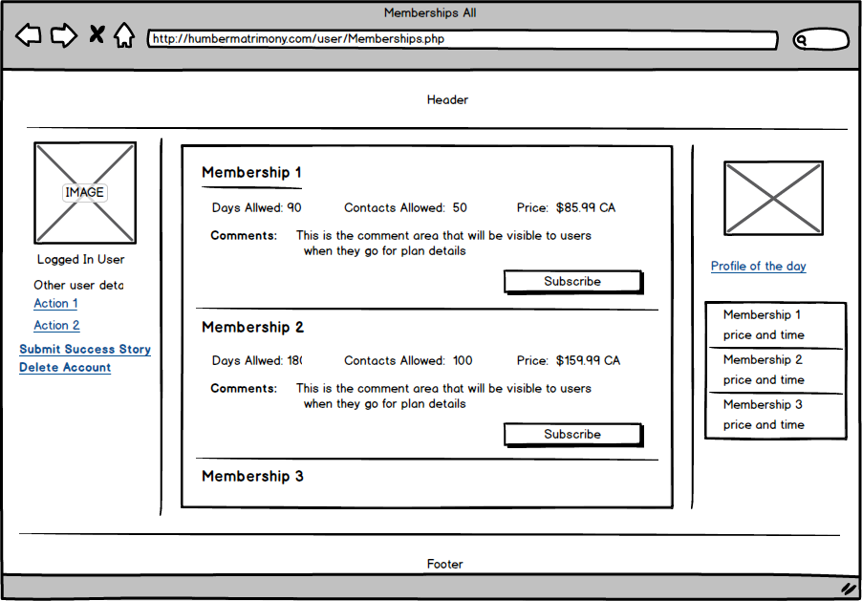

Wireframe to add new membership plan by admin section

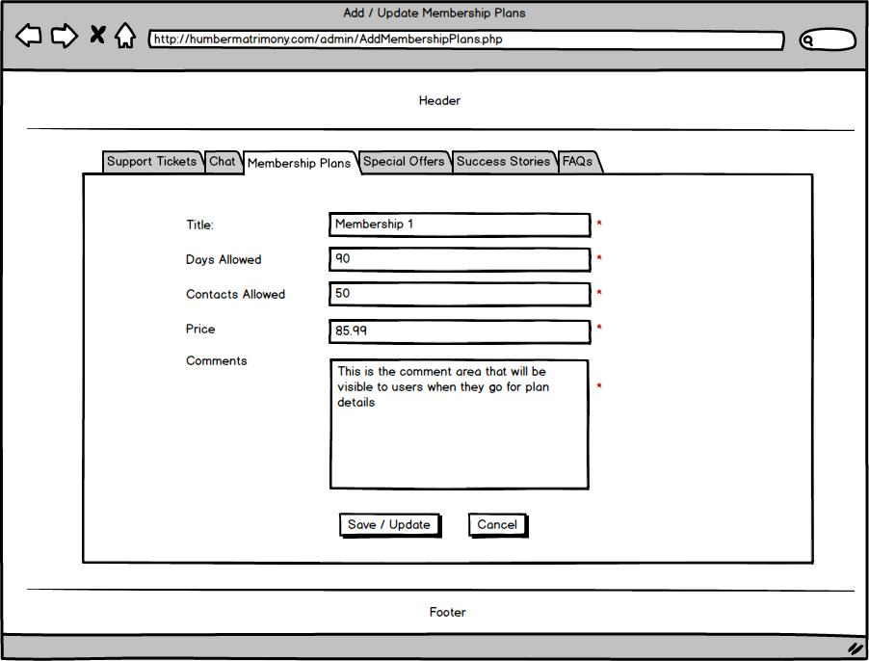

Wireframe to provide credit card information

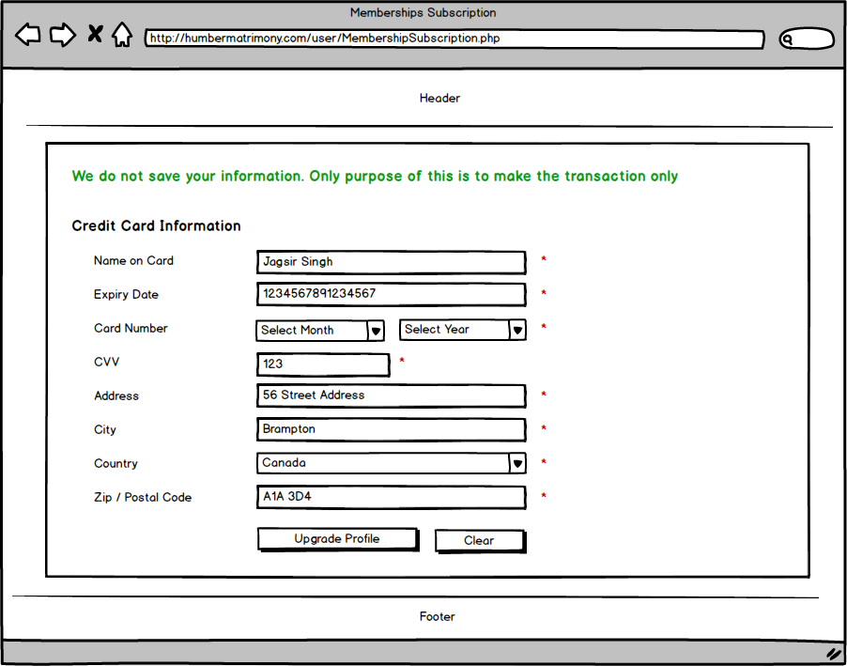

Wireframe to display all membership plans to public users

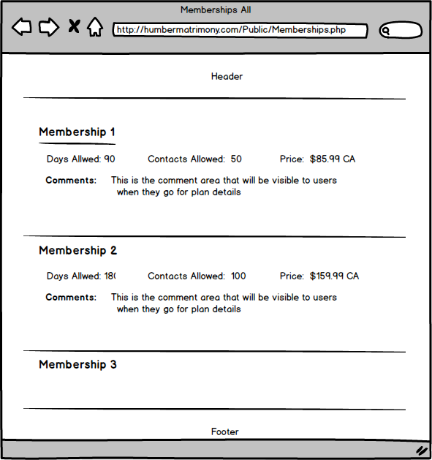

Here is the wireframe to confirm the order when user goes for subscription

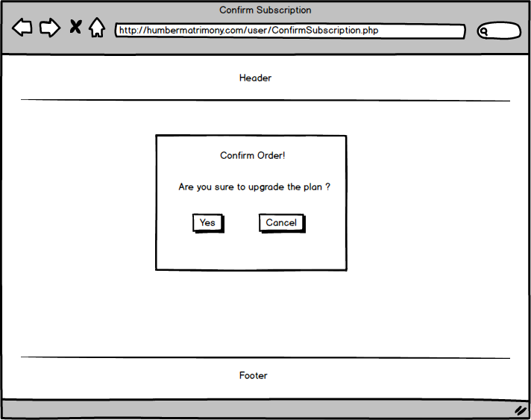

Wireframe to display the message after the successful transaction

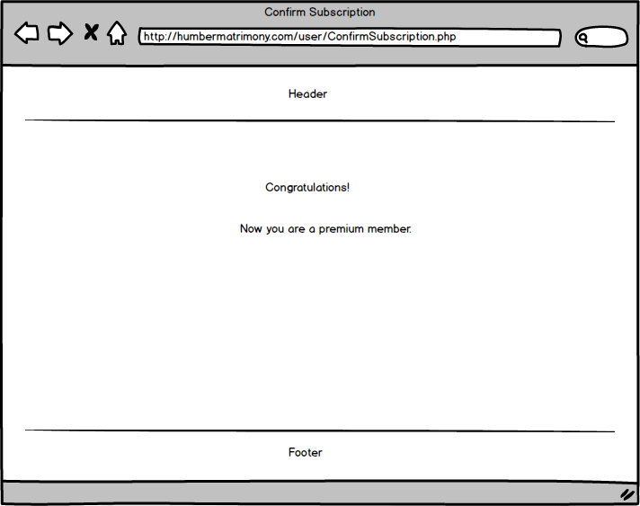

Help Desk

**Narrative Description**

In this feature, registered users will be able to initiate the chats with online agents of website. This chat is also not being stored in database. When user requests for the chat, request will go to queue and once the agent is available, chat will start.

For this chat, users must have to stay on the page to keep chatting. Once the user leaves the page, chat will no longer be available.

Database tables for this feature are below

tbl_HelpDeskRequests

|  |  |
| --- | --- |
| Help Desk Id | Numeric **(PK)** |
| User Id | Numeric |
| Subject | Text 45 characters |
| Message | Text 500 characters |
| Is Canceled | True / False |

**The Dataflow Models**

User needs to log in first and should go to help desk page. Here they provide department, subject, and reason (message) to initiate the chat. Once they provide the required information, next is the submit click. It will save the information in database so admin agent can see request. When agent sees chat request on dashboard, agent click on initiate link to create chat connection between two. If user is online then chat will begin. Chat will quit if any of them leaves the page or close the chat window.

Here is the dataflow model of complete chat request with agents

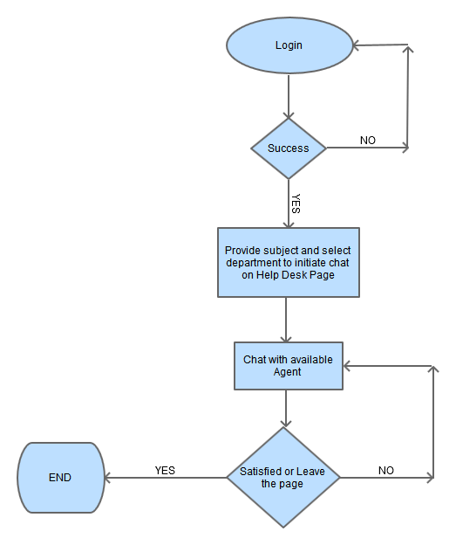

**Wireframes**

Here is the wireframe to send chat request by user

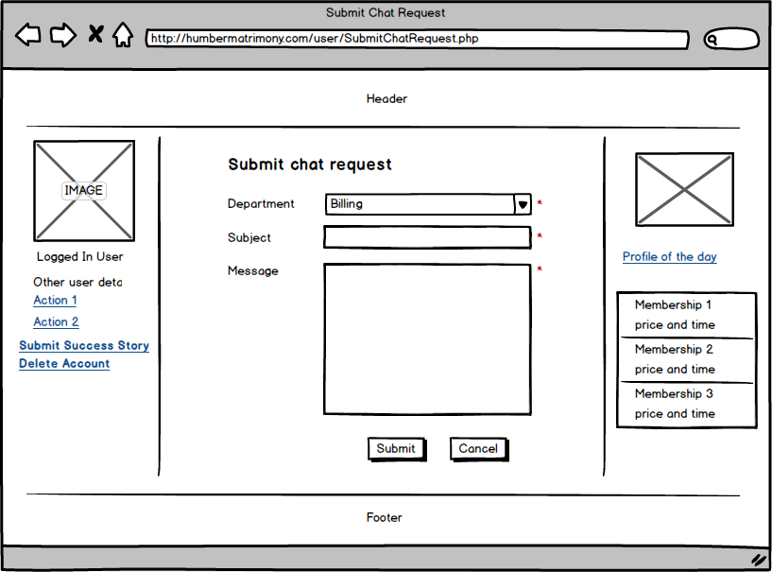

Wireframe to show complete list of chat requests in admin section

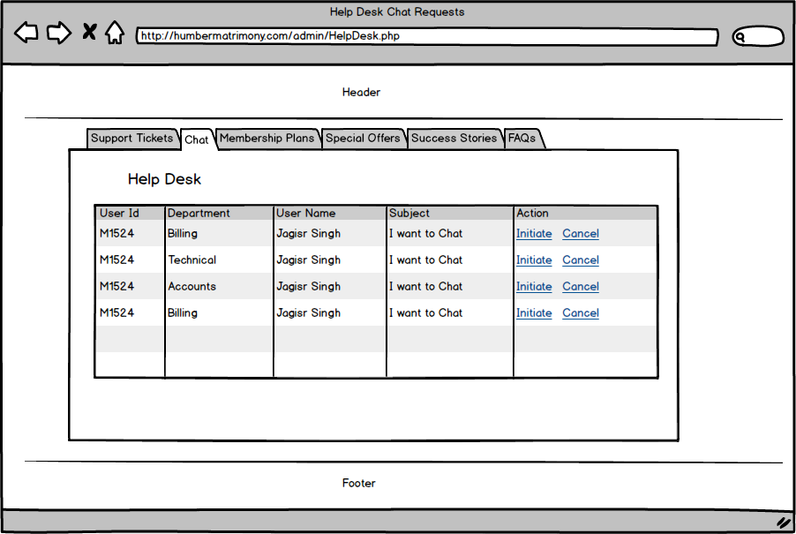

Wireframe for chat window

